AMBEO: Remarkable solutions for spatial audio production
The leading immersive technology attracts Japan’s famed Sonologic-Design studio

Tokyo, Japan, June 3, 2024 – Sennheiser has been pioneering the immersive audio scene as a key innovator and thought leader, particularly since its AMBEO VR MIC was launched in 2017. Since Dear Reality joined the Sennheiser Group in 2019, they have been working together to build the future of spatial audio production through the creation of innovative hardware and software solutions for the professional audio industry, developed under the AMBEO brand. With the growing global demand for spatial audio experiences, the need for audio software solutions that help production companies work more efficiently is also increasing. The renowned production company Sonologic-Design from Tokyo has long been a champion of spatial audio and Ambisonics. Its founder and CEO, Masato Ushijima, explains how AMBEO meets the industry’s need for more efficient workflows.

Sonologic-Design is a Tokyo-based production company that creates sounds for gaming, films, various entertainment spaces, and mobility. Masato Ushijima, the company’s founder, has always sought the best solutions to optimize extremely complex workflows. For years, the company has relied on AMBEO hardware and software solutions to boost the creative production process.

“When it comes to spatial audio software workflows, Dear Reality’s tools are essential for professional sound studios like ours. We use the dearVR PRO 2 spatializer plugin and the dearVR SPATIAL CONNECT VR controller application for many of our projects including the award-winning video game Hi-Fi RUSH. We mixed the sounds for the game in this studio, fully utilizing Dear Reality. Additionally, we have used these plugins to create sounds for theme park attractions and product launch events.”

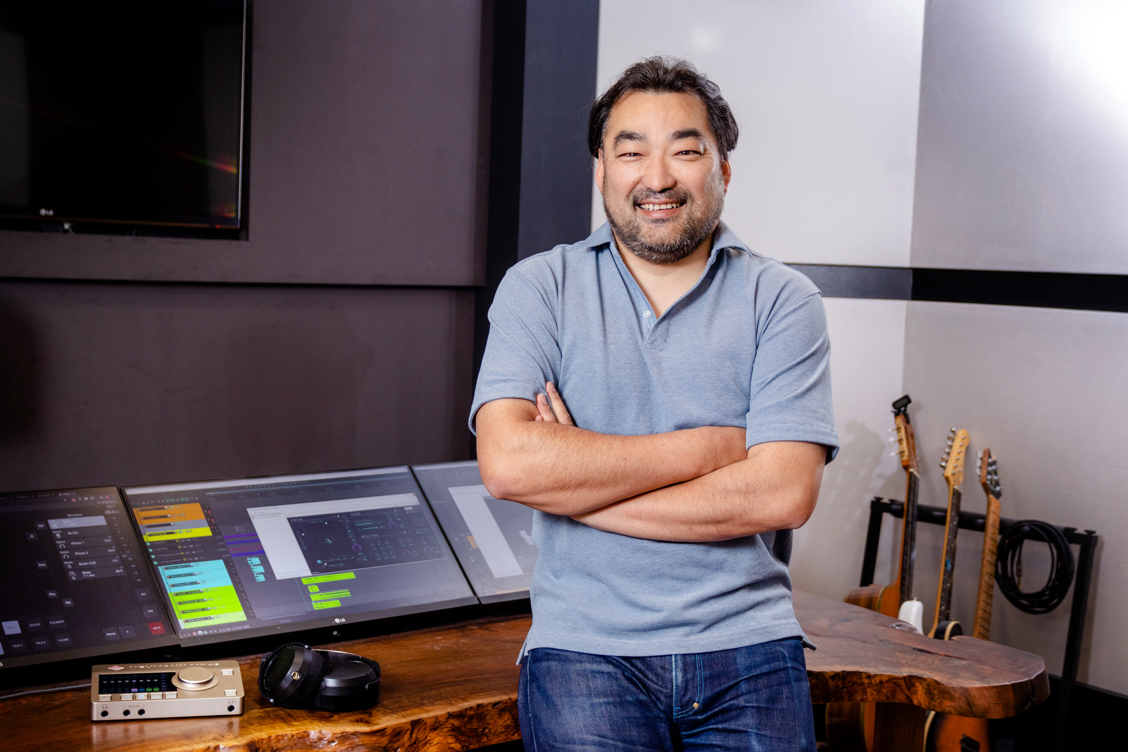
Masato Ushijima - CEO of Sonologic-Design Inc.

Masato explains that the greatest strength of dearVR PRO 2 spatializer lies in its ability to maintain the natural spatial sound quality when working in Ambisonics or multi-channel loudspeaker formats. “Normal panner plugins can specify directions but not distances. Some plugins also require equalizer adjustments, which increases complexity and then requires the use of multiple software tools. With dearVR PRO 2, we can set various parameters, such as distances, on a single screen. This significantly reduces the time required for this step and greatly improves our efficiency. For creators, this is a truly helpful function.”
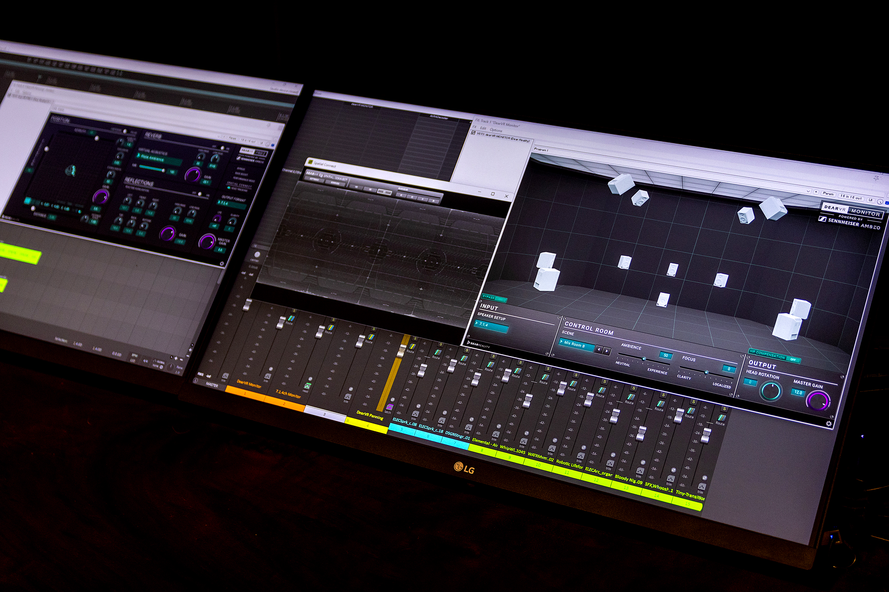
Spatial audio production workflow with dearVR PRO 2 (left), dearVR SPATIAL CONNECT (mid), and dearVR MONITOR (right).

Another strength he highlights is its superior usability. In the process of immersive audio mixing, creators need to set three-dimensional positions and automations for hundreds of tracks. This complexity would require a significant amount of time if all parameters had to be set on regular screens. With the dearVR SPATIAL CONNECT VR controller application, which connects a VR headset to the DAW and enables extensive control of dearVR PRO 2 positional controls, positioning and automating in immersive audio formats becomes more natural.

Masato believes that these strengths come from the fact that Dear Reality has its origins in binaural and Ambisonics technology. He points out that the software tools can help address the shortage of immersive audio experts on the market by reducing the need for heavy investment in hardware products. For many professionals, this presents a bottleneck to becoming experts in this field. Masato also provides the example of the dearVR MONITOR immersive mix room plugin, which simulates a virtual mixing environment with immersive loudspeaker formats up to 7.1.4 or 9.1.6 over standard headphones: “This is a great starting point for us to produce the desired sound image.”

Before spatial audio became mainstream in the industry, Masato had already discovered that Ambisonics would be a key trend for the future. In 2017, he had teamed up with Sennheiser Japan to record a quartet performance with AMBEO VR MIC for the first time: “The release of AMBEO VR MIC was truly exciting. I remember that it was the first Ambisonics-based VR microphone at an affordable price for semi-professionals and broader creators. I have used it for many projects. Today, AMBEO VR MIC continues to offer a great advantage as its captured sound can be used directly in the Dear Reality software.”

“Sennheiser’s AMBEO solutions are essential technologies for audio production in many fields from gaming to mobility. As part of AMBEO, I truly recommend professionals to use Dear Reality software to achieve high-quality sounds efficiently”, concludes Masato.

About the Sennheiser Group
Building the future of audio and creating unique sound experiences for our customers - this is the aspiration that unites the employees of the Sennheiser Group worldwide. The independent family-owned company Sennheiser was founded in 1945. Today, it is managed in the third generation by Dr. Andreas Sennheiser and Daniel Sennheiser and is one of the leading manufacturers in the field of professional audio technology.

sennheiser.com | neumann.com | dear-reality.com | merging.com

